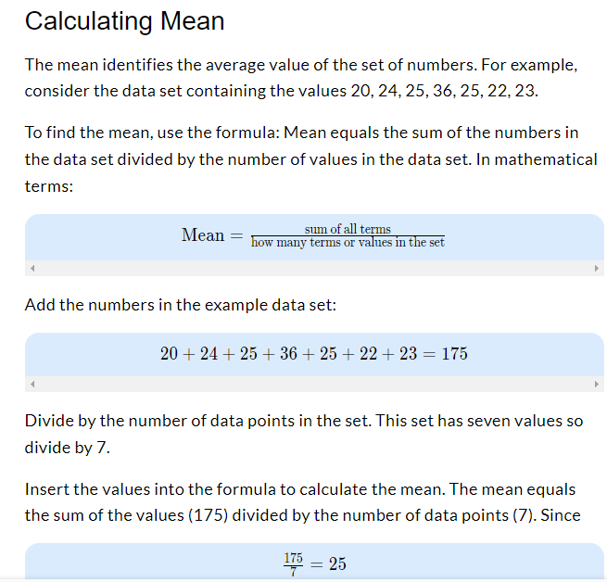

### Calculating Median

The median identifies the midpoint or middle value of a set of numbers.

Put the numbers in order from smallest to largest. Use the example set of values: 20, 24, 25, 36, 25, 22, 23. Placed in order, the set becomes: 20, 22, 23, 24, 25, 25, 36.

Since this set of numbers has seven values, the median or value in the center is 24.

If the set of numbers has an even number of values, calculate the average of the two center values. For example, suppose the set of numbers contains the values 22, 23, 25, 26. The middle lies between 23 and 25. Adding 23 and 25 yields 48. Dividing 48 by two gives a median value of 24.

### Calculating Mode

The mode identifies the most common value or values in the data set. Depending on the data, there might be one or more modes, or no mode at all.

Like finding the median, order the data set from smallest to largest. In the example set, the ordered values become: 20, 22, 23, 24, 25, 25, 36.

A mode occurs when values repeat. In the example set, the value 25 occurs twice. No other numbers repeat. Therefore, the mode is the value 25.

In some data sets, more than one mode occurs. The data set 22, 23, 23, 24, 27, 27, 29 contains two modes, one each at 23 and 27. Other data sets may have more than two modes, may have modes with more than two numbers (as 23, 23, 24, 24, 24, 28, 29: mode equals 24) or may not have any modes at all (as 21, 23, 24, 25, 26, 27, 29). The mode may occur anywhere in the data set, not just in the middle.

Calculating Range

Range shows the mathematical distance between the lowest and highest values in the data set. Range measures the variability of the data set. A wide range indicates greater variability in the data, or perhaps a single outlier far from the rest of the data. Outliers may skew, or shift, the mean value enough to impact data analysis.

In the sample group, the lowest value is 20 and the highest value is 36.

To calculate range, subtract the lowest value from the highest value. Since

36-20=1636−20=16

the range equals 16.

In the sample set, the high data value of 36 exceeds the previous value, 25, by 11. This value seems extreme, given the other values in the set. The value of 36 might be an outlier data point.

